Science TEKS: 3.11, 4.6, 5.3, 5.1, 5.2, 5.4, 5.5, 5.6 Name_____KEY______________
Math TEKS: 5.11, 5.14, 5.15

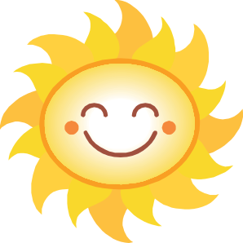
Did you know? Cumulonimbus clouds can hold up to half a million tons of water!

Lesson Two: Physical Properties of the Atmosphere

Overview. Today, you will take your first measurements outside! You will be measuring the amount of ozone in the air, the humidity, the wind direction, the air temperature, and the temperature of some surfaces. You will also be able to observe the types of clouds that are in the sky. You will take these measurements at both the beginning and at the end of the class.
You will also be learning about the layers of the atmosphere and about two physical properties of the atmosphere: temperature and wind.

Which instrument are you most excited to use today?
(Answers may vary)

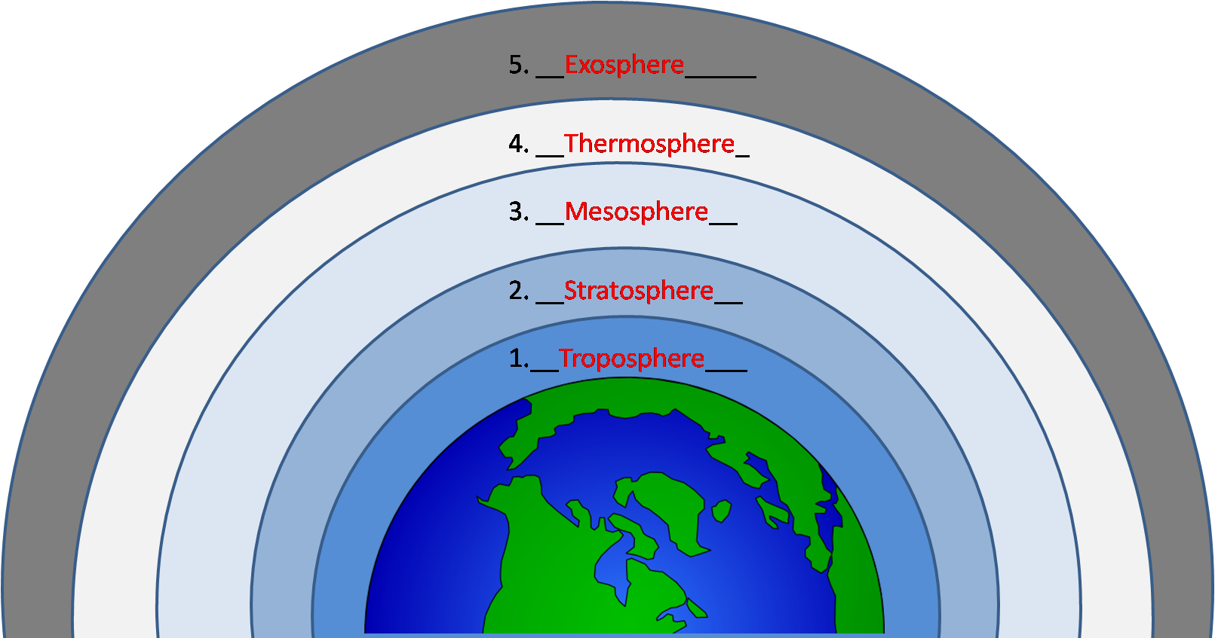
Label the layers of the atmosphere.
(Note: The actual atmosphere is very thin compared to Earth. It is drawn big here so you can label it.)
What is something that you might find in each layer?

1. Troposphere: Weather, clouds, rain, birds, airplanes, people
2. Stratosphere: Ozone layer
3. Meteors disintegrate
4. Thermosphere: Space shuttle
5. Exosphere: Satellites

Temperature
Which instruments do we use to measure temperature?
Digital (hygro-)thermometer for air temperature, and infrared thermometer for surface temperature.

What is an urban heat island? What causes it to occur?
An urban heat island is when a city is warmer than its surroundings. This occurs because urban surfaces such as asphalt and concrete heat up more quickly and allow less transpiration than vegetation, and because of waste heat from cars and buildings.

Wind
Which instrument do we use to measure wind direction?
Wind vane

What causes the wind to blow?
Differences in temperature lead to differences in pressure, which causes wind. An example of this is the sea breeze circulation that arises due to temperature differences between the land and sea.
You have begun measuring surface temperature and air temperature with your GLOBE measurements.

Which instruments did you use to measure surface temperature and air temperature?
_Surface temperature is measured with the infrared thermometer, and air temperature with the digital hygro-thermometer__

What types of objects did you measure for surface temperature?
_Answers may vary depending on what was__ __measured___________________________________________________________________

Which object had the warmest surface temperature? Why do you think that object was warmer than the other objects?
___Answers may vary___ _____________________________________________________________________________________________________________________

